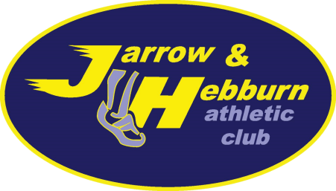

Annual General Meeting of Jarrow and Hebburn Athletic Club Ltd.
Company no. 11005376
Date: Monday 7 September 2020
Time: 6.30pm
Venue: Online via Microsoft Teams

Agenda
- Welcome and apologies
- Minutes and actions of 2019 AGM
- Election of company directors
- Election of committee members
  - Chair
  - Treasurer
  - Secretary
  - Membership Secretary
  - Welfare Officers
  - Other Committee positions
- Club captains (Non-committee positions)
- Club accounts and Treasurer’s report
- Secretary’s report
- Chair’s round-up and Club’s future plans
- Any Other Business

