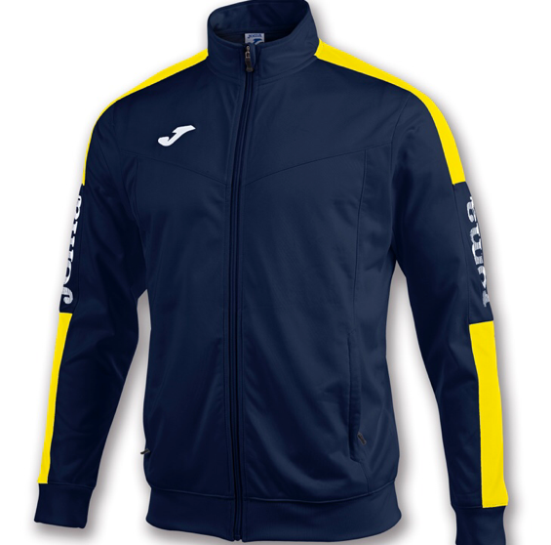
Jarrow & Hebburn A.C Clothing Available NOW !
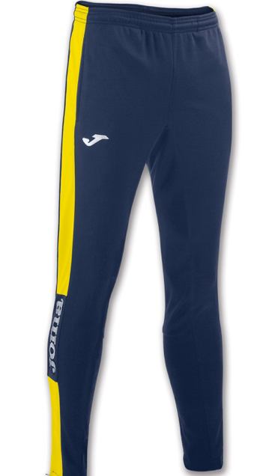
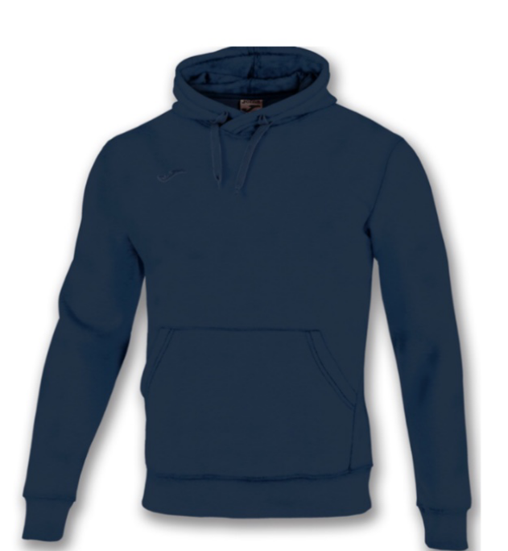
Joma Champion Track Bottoms

Joma Champion Track Top

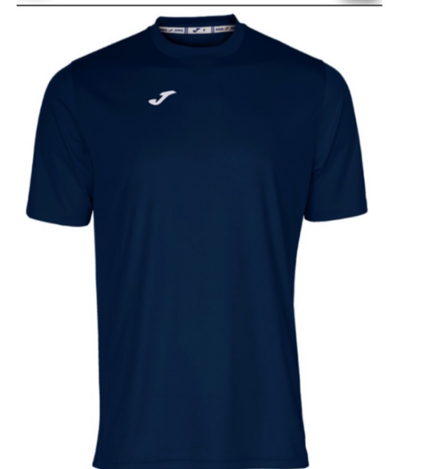
Joma Navy T- Shirt
Joma Navy Hoodie

All items are available in both Children & Adult sizes.
All tops will include the club logo embroidered to the front right side and Jarrow & Hebburn A.C printed on the back.

Size Guide as below
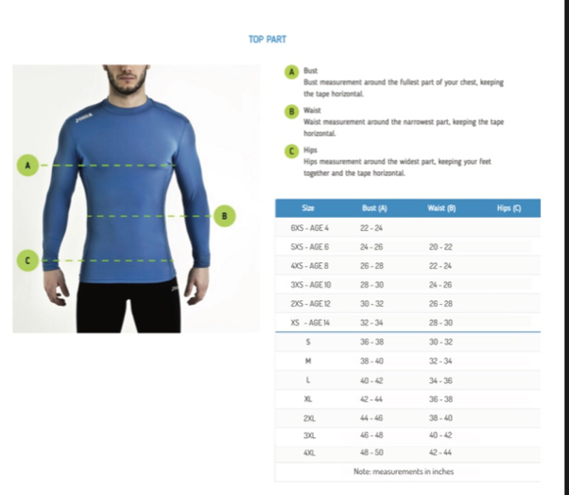
A non- branded hoodie is also available in the following sizes.

Jarrow & Hebburn AC Club Vests Sizes
Junior - 26” & 28” = £12.50
Adult - 30”,32”,34”,36”,38”,40”, 42”, 44” = £17.00
Adult Sizes
- Small – 34/36 inch
- Medium – 38/40 inch
- Large – 42/44 inch
- X-Large – 44/46 inch

Children’s Sizes
- XS - 3-4 yrs (32Inch)
- S - 5-6yrs (34 inch)
- M - 7-8yrs (36 inch)
- L – 9-11yrs (38inch)
- XL – 12-13yrs (40inch)

CLUB CLOTHING ORDER FORM
NAME
CONTACT NUMBER
COACHING GROUP

Item | Price | Size  Please Tick | Quantity Required | Total
J&H AC Vest | - Junior £12.50  - Adult £17.00
Joma Champion  Track Top | - Junior £18.88  - Adult £21.02
Joma Champion  Track Bottoms | - Junior £14.56  - Adult £17.57
Joma Hoodie | - Junior £23.85  - Adult £27.77
Joma combi  T-Shirt | - Junior £11.25  - Adult £11.95
Unbranded Hoodie | - Junior £14.78  - Adult £16.59

Total Amount Due
Payment Method
Date Received

If you would like to place an order please pop into the clubhouse on a Tuesday evening. If you are paying with cash please ensure it is the exact amount. If you would like to pay by BACS please ensure you reference your order or we will not be able to process.

Alternatively, you can visit Bolam Sport in South Shields, they have sample sizes and you will be able to place an order with them directly.
Rekendyke Industrial Estate, South Shields, NE33 5BZ – 0191 340 9311
bolampremiersportswear.co.uk

