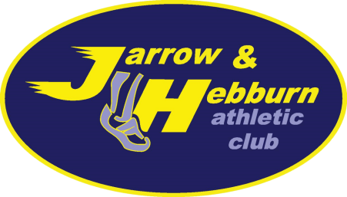

Annual General Meeting of Jarrow and Hebburn Athletic Club Ltd.
Company no. 11005376
Date: Monday 28 June 2021
Time: 6.30pm for start at 7pm
Venue: The Lakeside Inn, East Fellgate Farm, NE10 8YD
Event will also be streamed online.
Agenda
- Welcome and apologies
- Minutes and actions of 2020 AGM for approval
- Election of company directors
- Election of committee members
  - Chair
  - Treasurer
  - Secretary
  - Welfare Officer
  - Other Committee positions
- Club accounts and Treasurer’s report
- Secretary’s report
- Chair’s round-up and Club’s plans
- Any Other Business

